The Tenth Anniversary Leeds 10th Anniversary Shirley M Shields
A demonstration dance in four figures, each of 32 bars, in strathspey time.
Figure 1
1-2 | 1st and 3rd ladies, 2nd and 4th men dance right hands across to opposite place.
3-4 | 1st lady casts around 3rd man, 2nd man around 4th lady, 3rd lady around 1st man and 4th man around 2nd lady, as in diagram 1, to finish in diagonal lines.
5-8 | All turn opposite person once round with both hands.
9-12 | 1st and 3rd ladies, 2nd and 4th men dance right hands across to opposite sides and cast behind partners, as in diagram 2, to finish on the other diagonal.
13-16 | All turn opposite person once round to finish in original places (square set).
17-32 | 1st and 3rd men, 2nd and 4th ladies repeat bars 1-16, forming diagonals as in diagrams 3 and 4 and finishing in original places (square set).  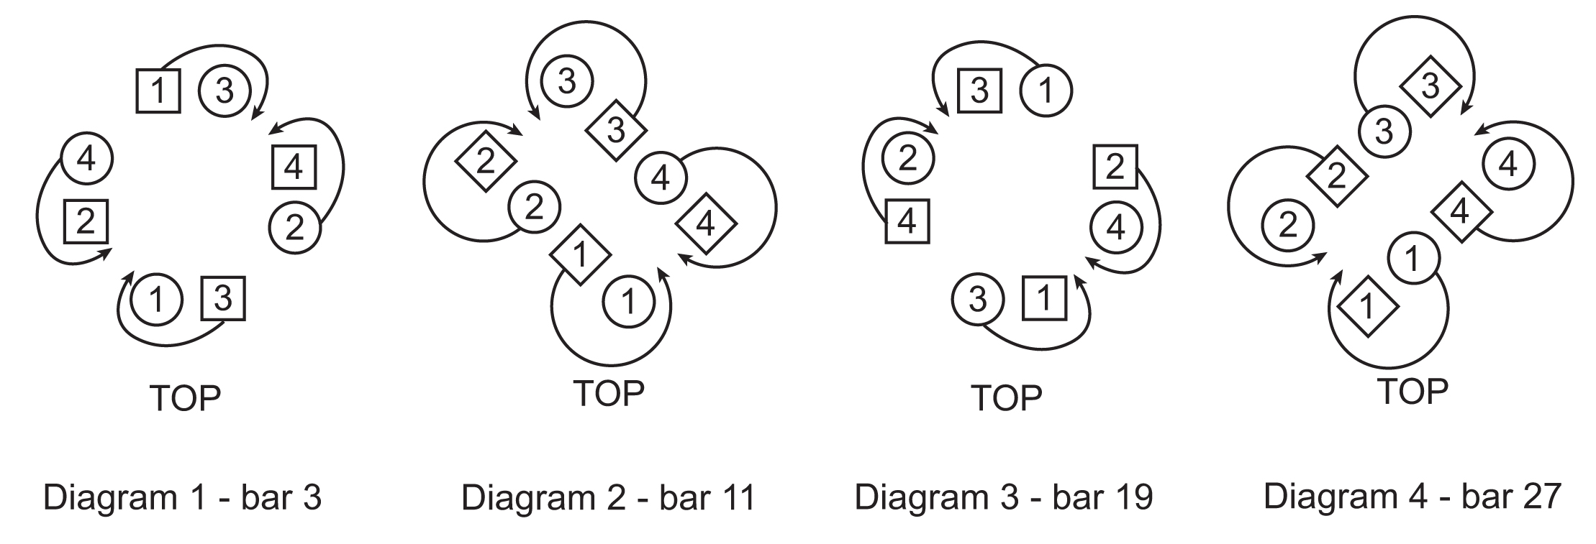
Figure 2
1-4 | All set and turn partners with both hands to finish with ladies back to back facing partners in diagonal lines as in diagram 5.
5-8 | 1st and 4th couples, 2nd and 3rd couples dance ½ reel of four, giving right shoulders to partners.
9-12 | Men dance ½ rights and lefts on the outside of the set.
13-16 | Ladies dance ½ rights and lefts to finish facing partners as in diagram 6.
17-20 | All set to and turn partner once round.
21-32 | Repeat bars 5-16, finishing in original places (square set).  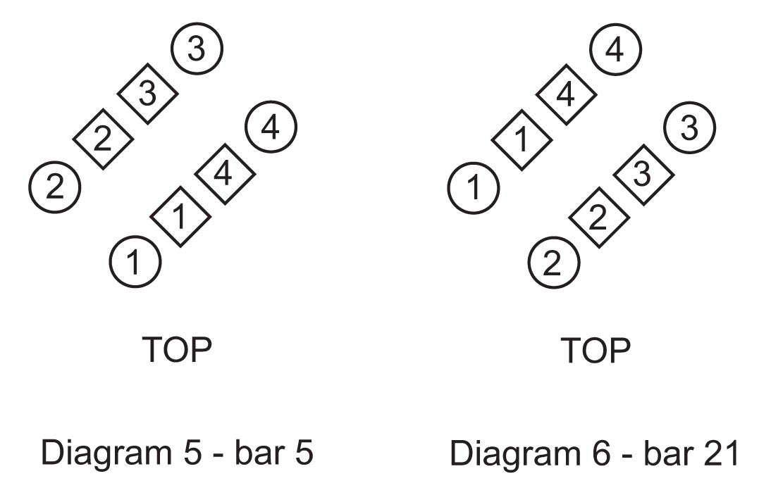
Figure 3
1-2 | All turn partners by the right hand to finish in a double wheel, ladies on the inside giving right hands across and each couple moving ⅛ round as in diagram 7.
3-4 | All dance ¼ round.
5-6 | Ladies turn the man ahead (who turns left about to meet her) by the left hand to finish in his place, the men giving right hands across to form the double wheel. See diagram 8.
7-8 | All dance ¼ round.
9-10 | Men turn the lady ahead (own partner) by the left hand to finish in the double wheel, the ladies with right hands across.
11-12 | All dance ¼ round.
13-16 | All turn partners with both hands to finish with the men in their original places and the ladies back to back in the centre facing partner.
17-32 | Men, moving anti-clockwise and with highland travelling step, dance petronella, while the ladies are setting and moving on one place clockwise with petronella turns, keeping back to back. All finish in original places (square set).  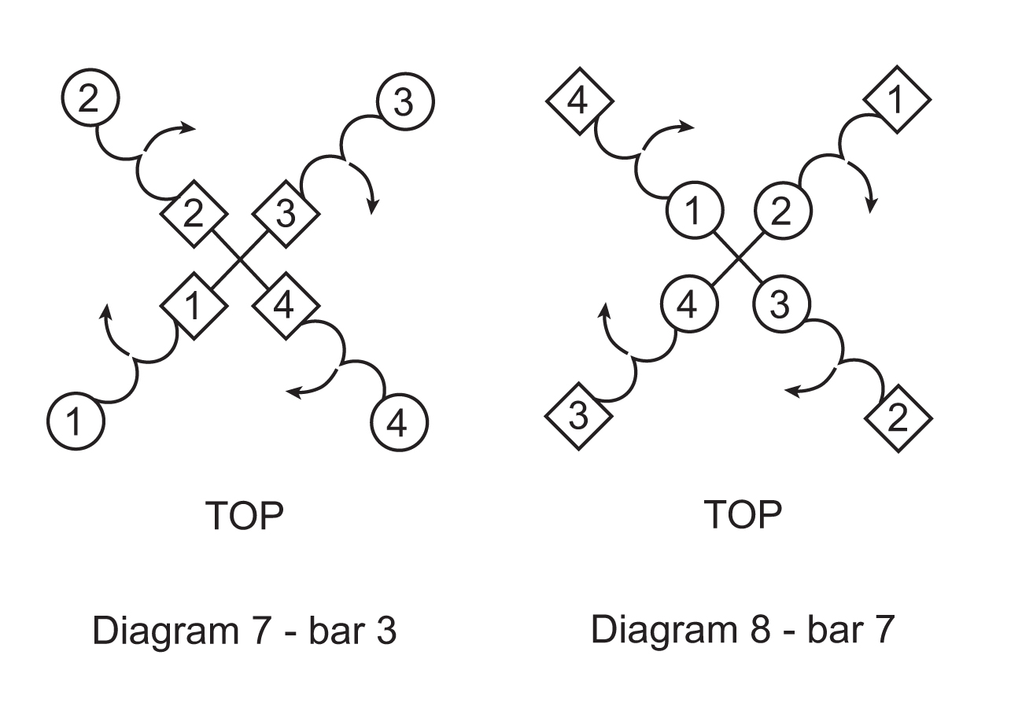
Figure 4
1-4 | Ladies dance four hands round to the left.
5-8 | Continuing to the left, the men join in and all dance eight hands round.
9-12 | Eight hands round to the right.
13-16 | Continuing to the right the men dance four hands round finishing back to back in the centre facing partners.
17-32 | Star grand chain, dancing in for two steps and out for two steps. The men move clockwise round the set and the ladies anticlockwise. All finish on the diagonal forming a cross with the men back to back in the centre for the final chord.

